_________CUSTOMERS ANALYSIS REPORT_______

-customers establishment analysis
Overview
The chart illustrates the correlation between customer tenure and the number of stable customers. The horizontal axis represents the duration of customer tenure, while the vertical axis indicates the count of stable customers.

Key Findings
- Initial Tenure Period:
A significant peak is observed at the beginning, reflecting a high number of stable customers during the early stage of engagement. This suggests effective customer acquisition strategies at the outset.

- Mid-Tenure Period:
Following the initial peak, the chart shows a sharp decline, stabilizing at a relatively low level. This indicates potential customer attrition or insufficient engagement during the mid-tenure stage.

- Late Tenure Period:
Toward the end of the tenure, the number of stable customers rises again, culminating in another peak. This highlights that long-term customers tend to demonstrate stronger loyalty and stability.

Strategic Implications
The analysis underscores the challenge of retaining customers during the mid-tenure phase. To address this issue, organizations should consider:
- Conducting root-cause analysis of customer churn in the mid-tenure stage
- Enhancing customer engagement and service quality during this period
- Introducing targeted loyalty programs and incentives to strengthen retention

Conclusion
The final peak demonstrates that long-term customer retention delivers substantial value. Strategic investment in sustaining customer relationships over extended periods is likely to yield significant business benefits.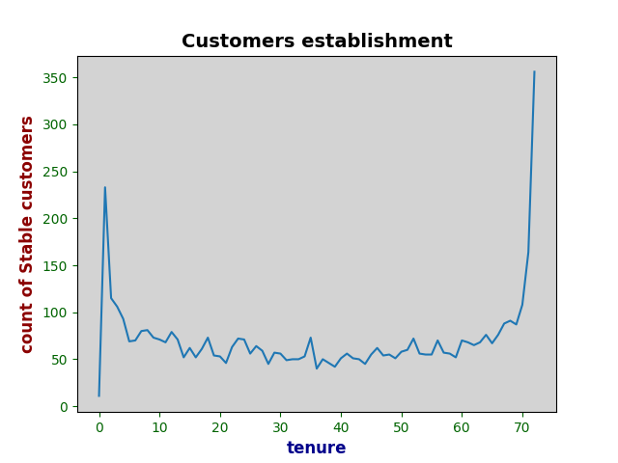
----------------------------------------------------------------------
-customers churn analysis
Overview
The chart illustrates the correlation between customer tenure and the number of stable customers. The horizontal axis represents the duration of customer tenure, while the vertical axis indicates the count of stable customers.

Key Findings
- Initial Tenure Period:
A significant peak is observed at the beginning, reflecting a high number of stable customers during the early stage of engagement. This suggests effective customer acquisition strategies at the outset.

- Mid-Tenure Period:
Following the initial peak, the chart shows a sharp decline, stabilizing at a relatively low level. This indicates potential customer attrition or insufficient engagement during the mid-tenure stage.

- Late Tenure Period:
Toward the end of the tenure, the number of stable customers rises again, culminating in another peak. This highlights that long-term customers tend to demonstrate stronger loyalty and stability.

Strategic Implications
The analysis underscores the challenge of retaining customers during the mid-tenure phase. To address this issue, organizations should consider:
- Conducting root-cause analysis of customer churn in the mid-tenure stage
- Enhancing customer engagement and service quality during this period
- Introducing targeted loyalty programs and incentives to strengthen retention

Conclusion
The final peak demonstrates that long-term customer retention delivers substantial value. Strategic investment in sustaining customer relationships over extended periods is likely to yield significant business benefits.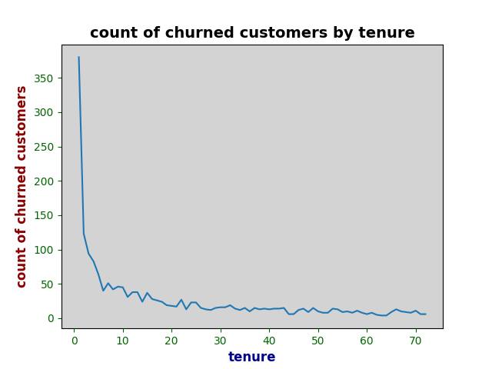
----------------------------------------------------------------------
-customers churn by contract analysis
Overview
This chart presents the distribution of churned customers based on their contract type. The x-axis categorizes contracts into three types: Month-to-month, One-year, and Two-year. The y-axis reflects the number of customers who have discontinued their service.

Key Findings
- Month-to-month contracts account for the overwhelming majority of churned customers, exceeding 1,600 individuals and representing 88.6% of total churn.
- One-year contracts show significantly lower churn, with approximately 150 customers, making up 8.9% of the total.
- Two-year contracts have the lowest churn rate, with fewer than 50 customers, representing just 2.6% of churned users.

Strategic Implications
The data clearly indicates that short-term contracts are highly correlated with customer churn, while longer-term contracts contribute to greater customer retention. This insight suggests several strategic actions:
- Encourage customers to opt for longer-term contracts through incentives, discounts, or added value.
- Analyze the pain points and dissatisfaction factors among month-to-month customers to reduce early churn.
- Design onboarding and engagement programs specifically tailored for short-term contract holders to boost retention.

Conclusion
Contract duration plays a critical role in customer retention. Businesses aiming to reduce churn should prioritize strategies that promote longer commitments and enhance the experience of short-term customers. Investing in contract-based retention models can lead to more stable customer relationships and improved lifetime value.
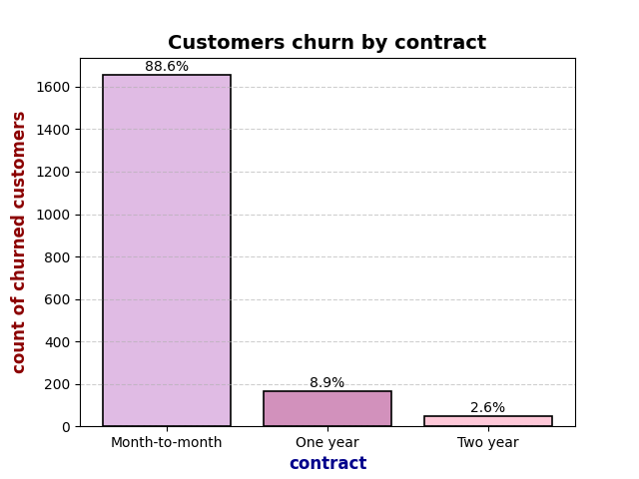----------------------------------------------------------------------
-customer churn by payment method analysis
Overview
This chart presents the distribution of churned customers based on their selected payment method. The x-axis categorizes payment types into four groups: Electronic check, Mailed check, Bank transfer (automatic), and Credit card (automatic). The y-axis reflects the number of customers who have discontinued their service.

Key Findings
- Electronic check users represent the highest churn rate, accounting for 57.3% of churned customers, with a count exceeding 1,000.
- Mailed check customers make up 16.5% of churned users.
- Bank transfer (automatic) accounts for 13.8%.
- Credit card (automatic) shows the lowest churn rate at 12.4%.

Strategic Implications
The data reveals a strong correlation between payment method and customer retention. Customers using automatic payment methods (bank transfer or credit card) are significantly less likely to churn compared to those using manual methods like electronic or mailed checks. Recommended actions include:
- Promoting automatic payment options during onboarding and renewal processes.
- Investigating the reasons behind high churn among electronic check users, such as payment failures or lack of convenience.
- Offering incentives or simplified transitions for customers to switch to automatic payment methods.

Conclusion
Payment method is a critical factor influencing customer retention. Encouraging the use of secure and automatic payment systems can reduce churn and enhance customer stability. Businesses should prioritize payment experience optimization as part of their broader retention strategy.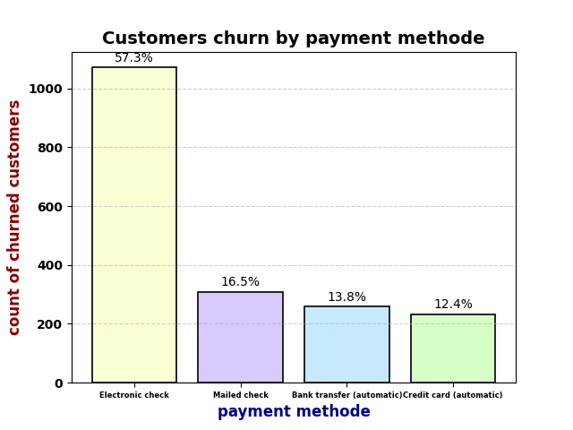----------------------------------------------------------------------

-churned customers VS stable customers analysis
Overview
This chart compares the number of churned customers and stable customers across different tenure periods (measured in months). The x-axis represents customer tenure, while the y-axis shows the count of customers in each category. Two lines are plotted: one for churned customers and one for stable customers.

Key Findings
- Churned Customers:
The churn rate is highest at the beginning of the tenure period. As tenure increases, the number of churned customers declines sharply and stabilizes at a lower level.

- Stable Customers:
The count of stable customers also starts high, dips during the mid-tenure period, and then gradually increases again, peaking toward the end of the tenure.

Strategic Insights
- The early tenure phase is a critical point for churn. Customers are most likely to leave during the initial months.
- Long-tenure customers show increased stability, indicating that retention improves significantly over time.
- The mid-tenure dip in stable customers suggests a potential engagement gap that may require targeted retention efforts.

Recommendations
To improve overall customer retention and stability:
- Strengthen onboarding and early engagement strategies to reduce initial churn.
- Monitor mid-tenure customer satisfaction and introduce re-engagement campaigns.
- Invest in loyalty programs and personalized experiences for long-tenure customers to reinforce commitment.

Conclusion
Customer behavior over tenure reveals a clear pattern: early churn is high, but long-term retention is strong. Businesses should prioritize early-stage support and long-term relationship building to maximize customer lifetime value.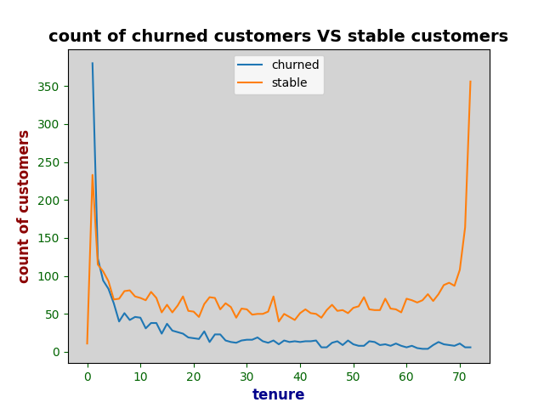----------------------------------------------------------------------

-distribution of customers churn by tenure
Overview
This chart visualizes the distribution of customer churn based on tenure (measured in months). The x-axis represents customer tenure, while the y-axis indicates the density of customers for both churned (Yes) and stable (No) categories. The chart uses a kernel density estimate (KDE) to show the distribution for both groups.
Key Findings
Churned Customers:
The churn rate is highest within the first 20 months of tenure, with a noticeable drop as customers continue their relationship with the company.
The highest concentration of churned customers is in the initial months, indicating that customers are most likely to leave early on.
Stable Customers:
Stable customers (those who have not churned) show a broader distribution across the tenure range, with more consistent numbers as tenure increases.
There is a steady increase in the number of stable customers after the initial months, indicating that those who stay beyond the early months are likely to stay longer.
Strategic Insights
Early Tenure Period:
The early months are the most critical for customer retention. Businesses should focus on providing strong engagement and value to prevent churn during this phase.
Long-Term Retention:
Customers who stay past the early churn phase tend to have longer tenures, indicating that retention efforts during the early stages can lead to greater stability in the long run.
Mid-Tenure Engagement:
The plot doesn't show a significant dip in stable customers during the mid-tenure period, but it suggests that as customers reach longer tenures, they might become less engaged. Continuous engagement efforts can maintain customer interest and prevent future churn.
Recommendations
To improve overall customer retention:
Focus on Early Engagement:
Strengthen onboarding processes and initial customer support to create a positive first impression and prevent early churn.
Targeted Retention Campaigns:
Implement engagement strategies during the first few months to retain customers who might otherwise churn.
Personalized Long-Term Engagement:
Offer loyalty programs and personalized experiences to customers with longer tenures to reinforce their commitment to the brand.
Conclusion
The chart highlights the critical importance of early-stage retention and engagement efforts to reduce churn. While customers who stay beyond the initial months tend to remain loyal, businesses must prioritize creating strong relationships in the early months and maintain continuous engagement for long-term stability.